# **Week 11 : Advanced Optimization models!**

Agenda:

* advanced knowledge week.
* advanced concepts in optimization
* assorted advanced models
* hands-on homework assignment to use optimization software.

# 11.1Optimization for statistical models

**Agenda:** use optimization model to obtain specific parameter or coefficients values for the statistical models seen before

### Linear regression

**Objective**: Minimize squared error in model’ estimates

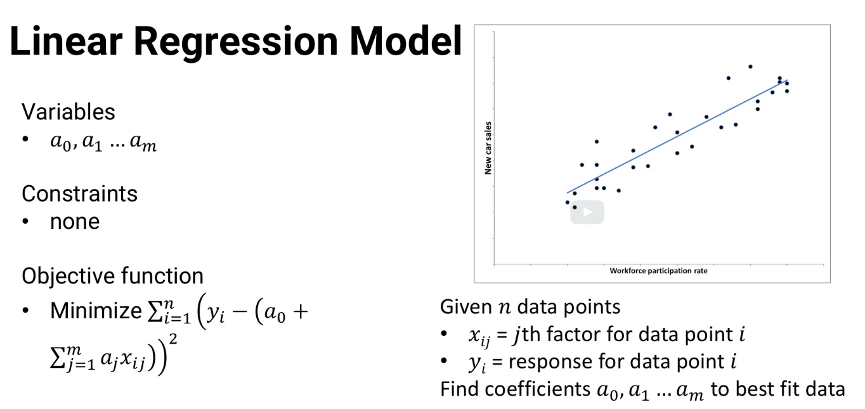

**Conflict in terminology between Statistics and Optimization model:**

1. **Statistics :** when we **see** linear regression as stat model, the component that change is x(ij) , data point which is variable that is different between data points
2. **Optimizaton:** It is opposite.below formula for optimization is error (SSE) which is (output –regression line) . in this case, the co-efficients are variables

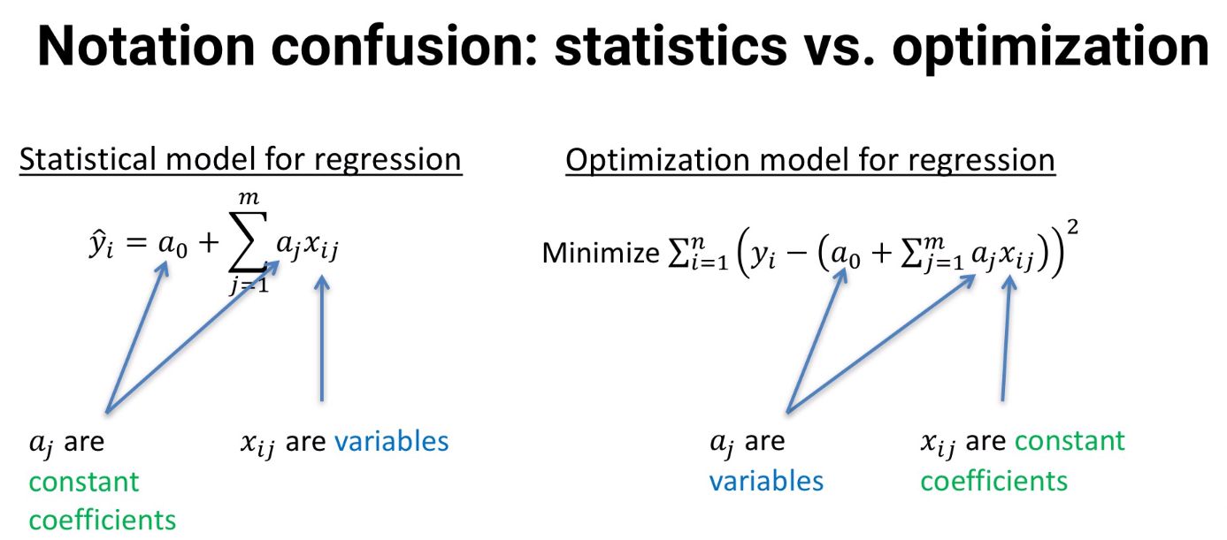

### LASSO

**-** It is standard regression with one constraint added to restrict “sum of the variables”

### RIDGE

**–** similar to lasso, but restriction(constraint) is on the square of the variables

### Elastic NET

**-** combines Lasso and Ridge

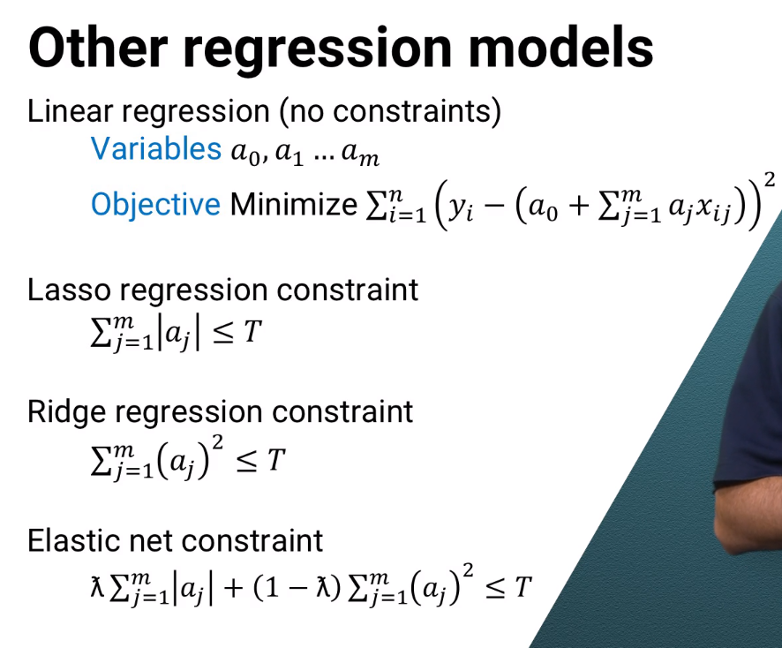

### Logistic regression:

-same as linear. Variables are coefficients

-no constraints

- Objective : **minimize prediction error** (function of bias and variation)

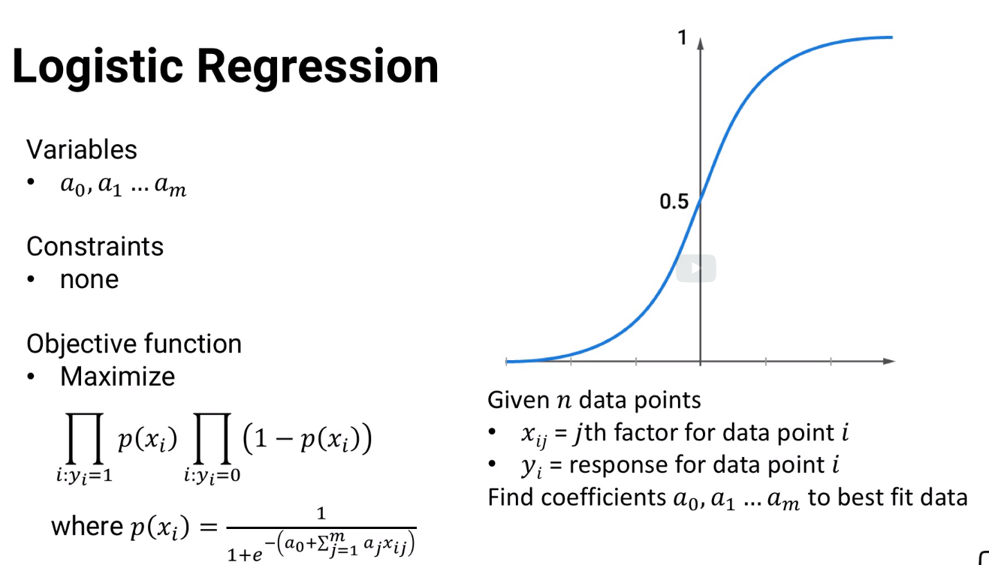

### SVM

**Hard Classification:**

Variables: a(0)..a(m)

Constraints: each data point are correctly classified

Objective: maximize distance or margin between support vectors

**SoftClassification:**

Variables: a(0)..a(m)

Constraints: N/A

Objective: It absorbds margin and classification errors

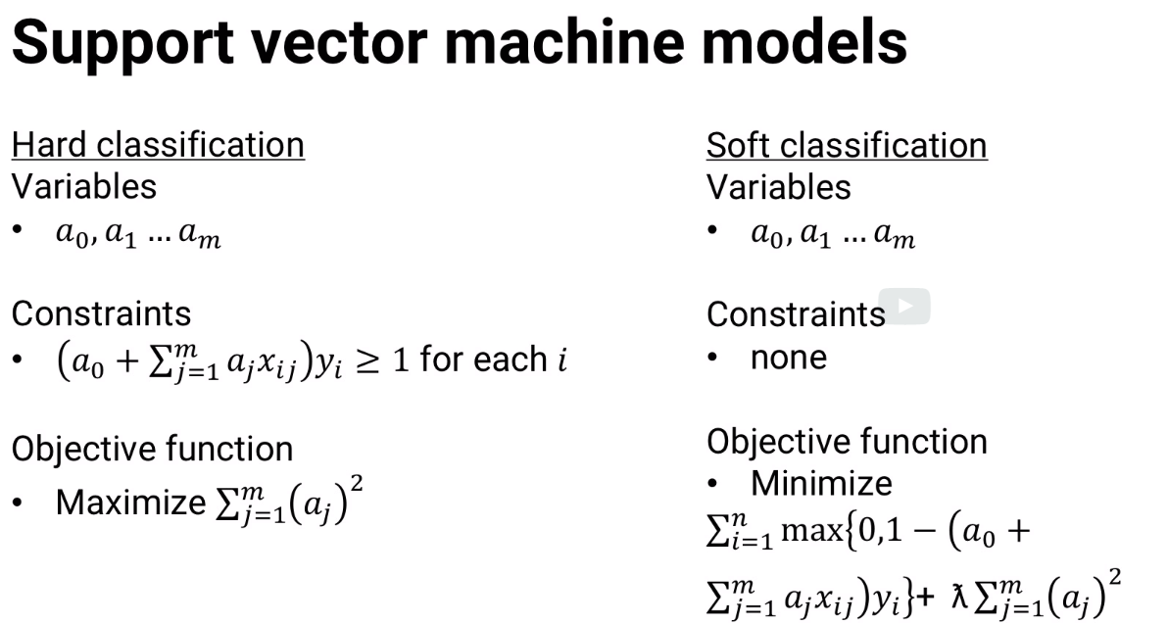

### Exponential Smoothing

**Objective:** minimize prediction error

**Constraints:** alpha, beta and gamme needs to be between 0 and 1

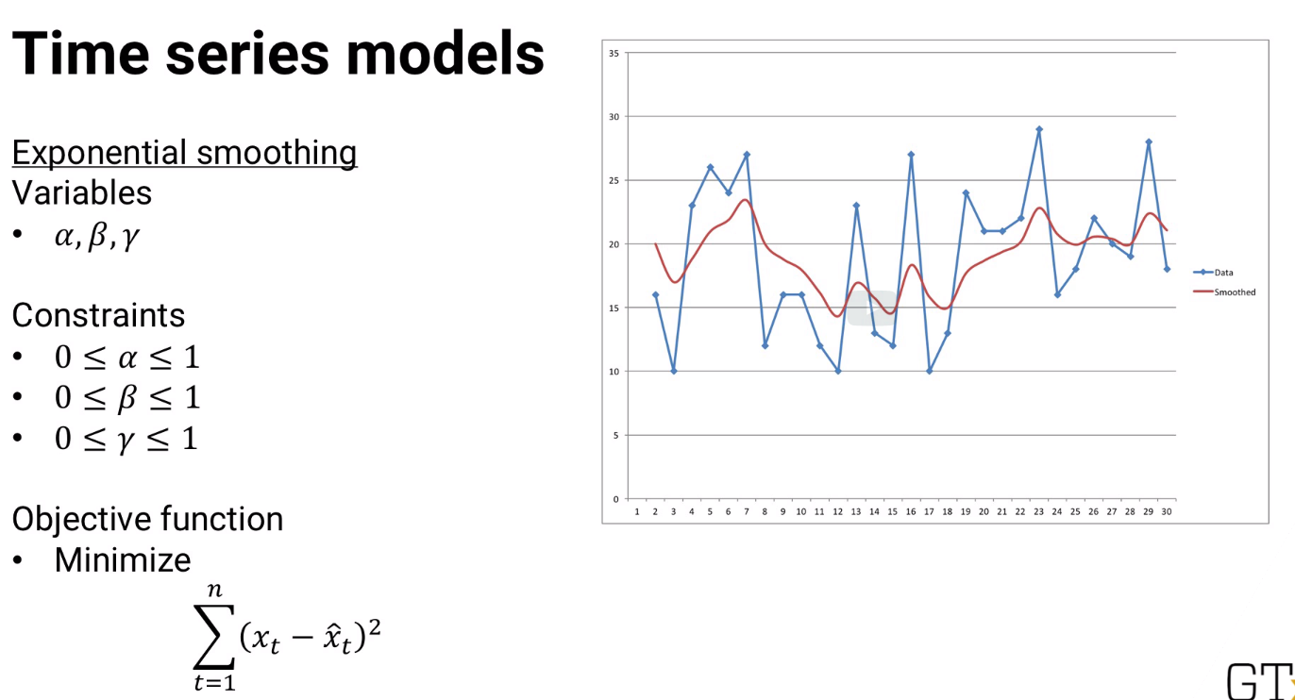

### ARIMA

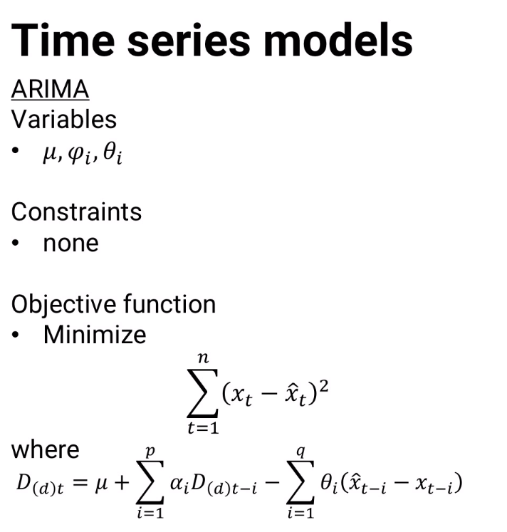

### GARCH

-same as ARIMA

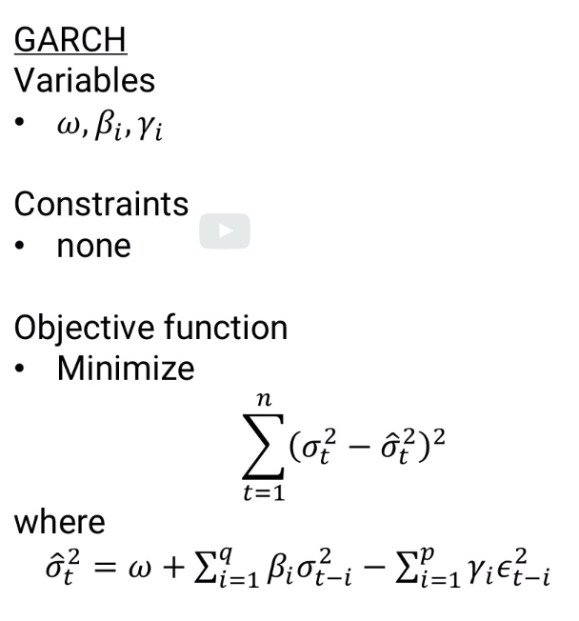

### CLUSTERING

Varaibles: 1) co-ordinates of cluster’ centroids

1. Binary variable whether each data point is part of each cluster

**Constraint:** each data point is assigned to one cluster ONLY

**Objective?:**minimize some of distance between each data point and cluster centroid

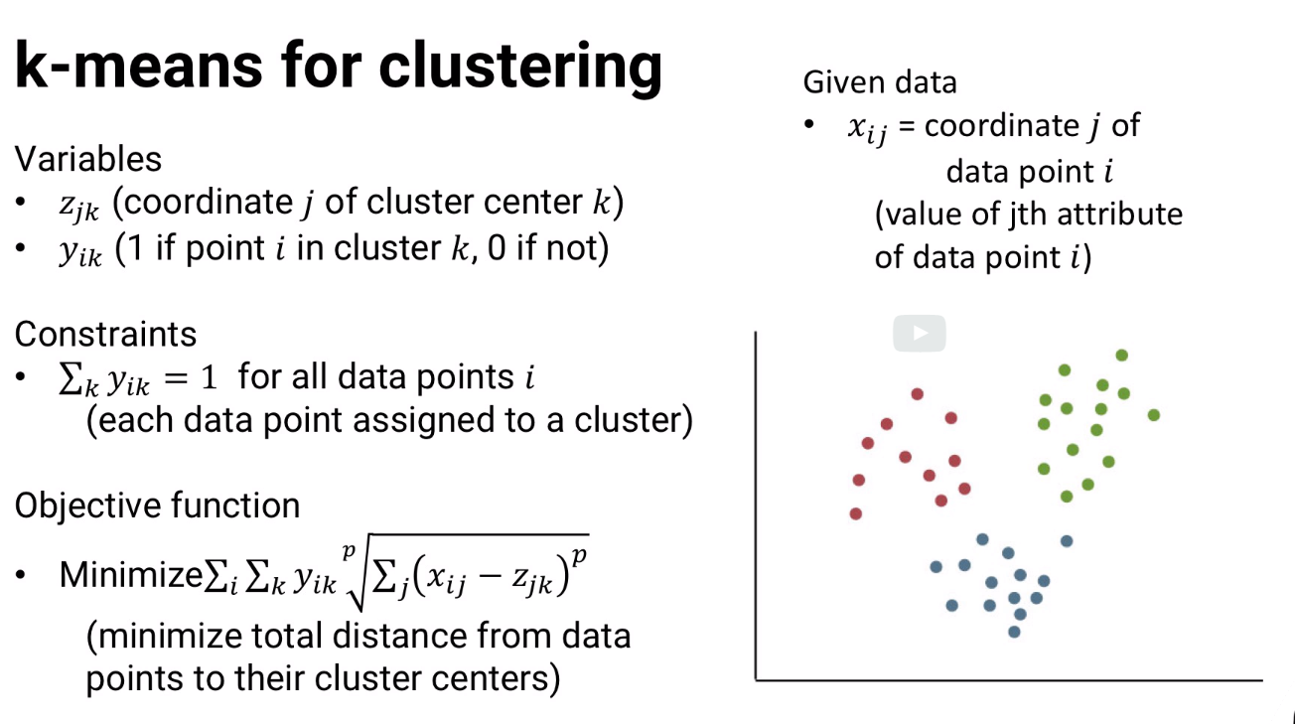

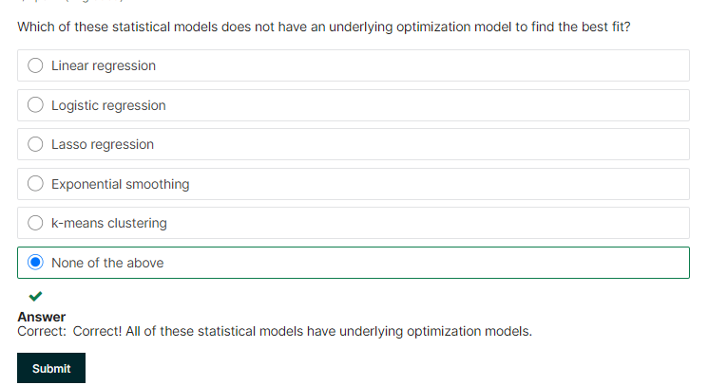

# 11.2 Classification of Optimization models

**Agenda:** based on math structure, some of the math models are easier and faster and some are slow and complicated

-understands which solve quickly

**General representation of Optimization models**

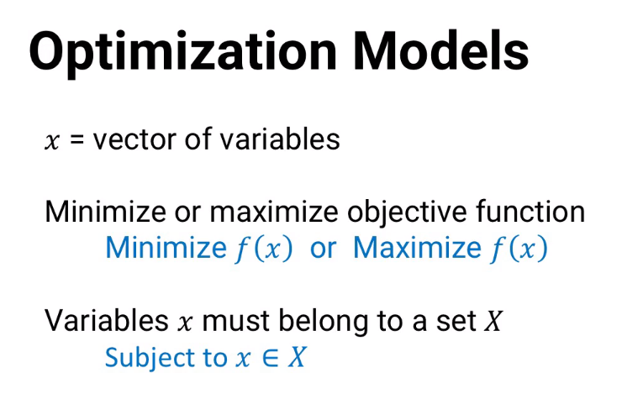

-above is very general and not useful for applied analytics

***So specialized versions below…***

***F(x) is OBJECTIVE***

## LINEAR PROGRAM

* Easy and fast to solve; good software can solve million variables and constraints

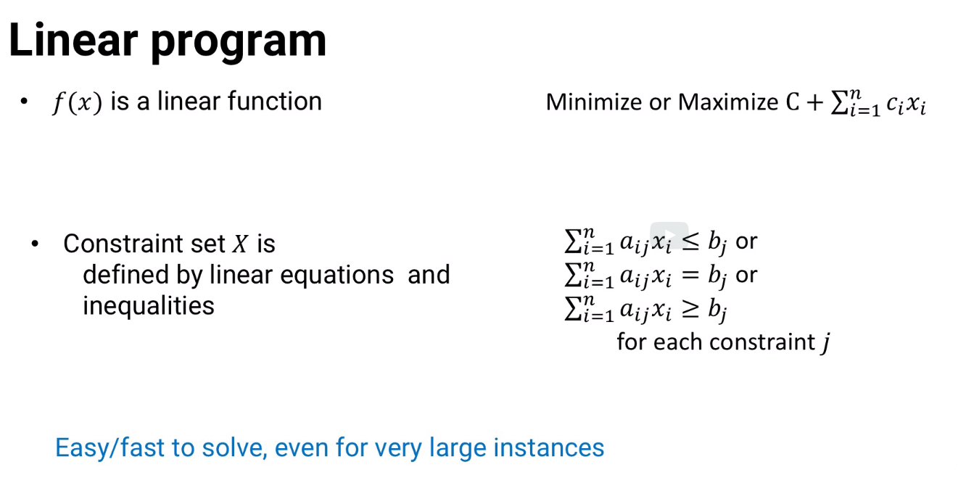

## CONVEX QUADRATIC PROGRAM

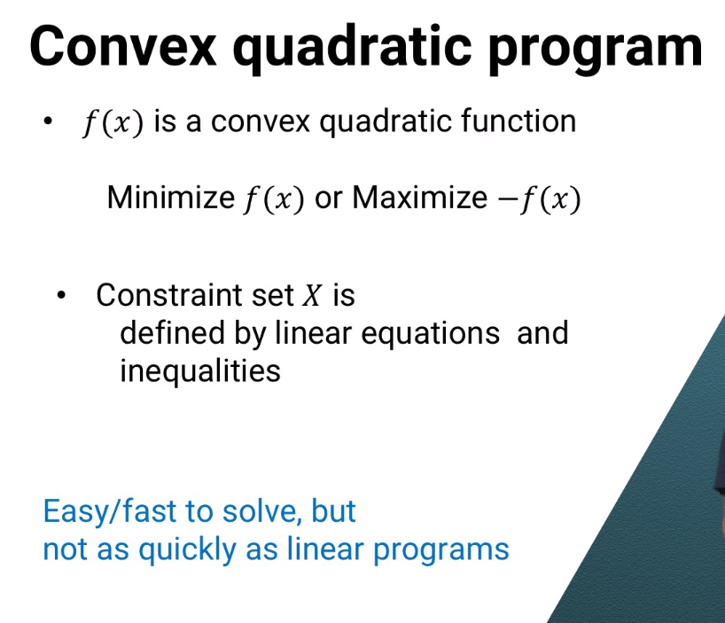

## CONVEX OPTIMIZATION PROBLEM

Suppose, f(x) is concave(if maximization problem) or convex(if minimizing) problem AND constrain X is convex set, easy to solve, but take longer time. This is convex Optimization problem

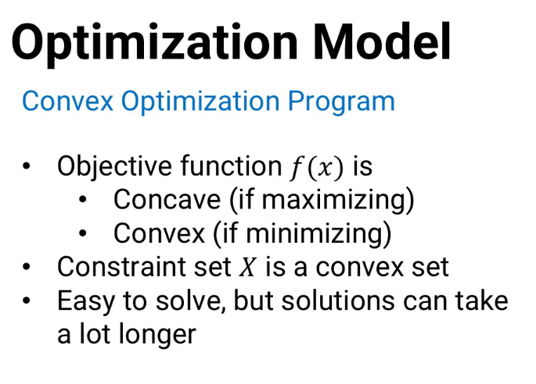

## INTEGER PROGRAM

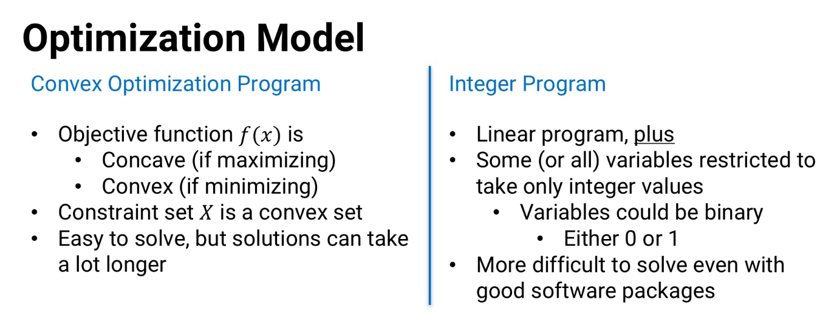

-even though binary variables are more restricktive integer values , Integer program still are difficult to solve

## GENERAL NON CONVEX PROGRAM:

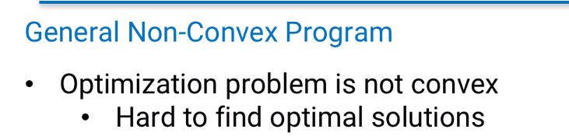

## Problem types and order of Quick/easy to slow/hard

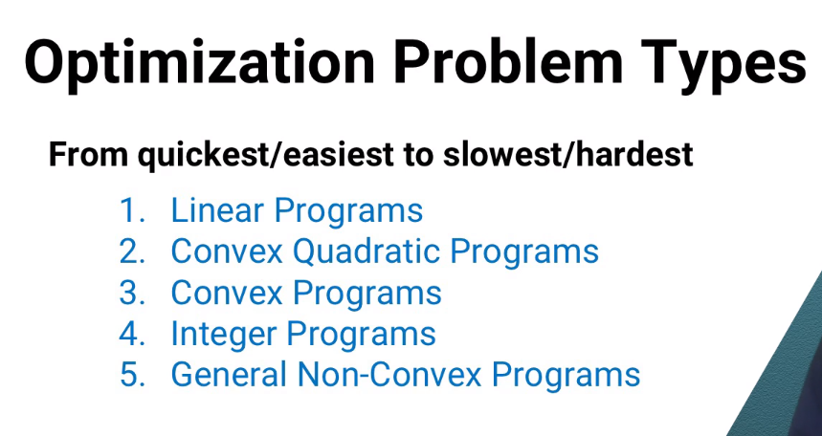

## Consolidation

|  |  |  |  |  |  |
| --- | --- | --- | --- | --- | --- |
|  | Linear | convex Quadratic | Convex Optimization | Integer | Non convex |
| Objects f(x) | Linear max or min X+sum of c(i)*x(i) | convex quadration min f(x) or maximise -f(x) | concave (if maximising) convex (if minimising) | linear program | NOT convex |
| constraint set X | linear equations and inqualities sum of a(ij)*x(i) <= b(j) or >-b or ==b | linear equations and inqualities | convex set |  |  |
|  |  |  |  | some variables take integer values -variables could be binary |  |
| Fast? | fast | fast(not as quickly as linear) | slow | slow | slow |
| Easy? | easy | easy | easy | difficult | difficult |

**Suggestion**

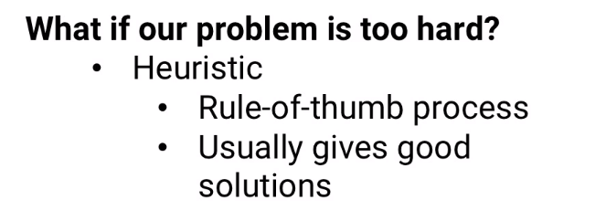

## *****NETWORK MODEL(Type of Linear program)

-can be solved more quickly than conventional linear program

**What is network model:** suppose we have a linear program that can be represented as below

set of locations called **nodes or vertices**

set of connections between them called **arcs or edges.**

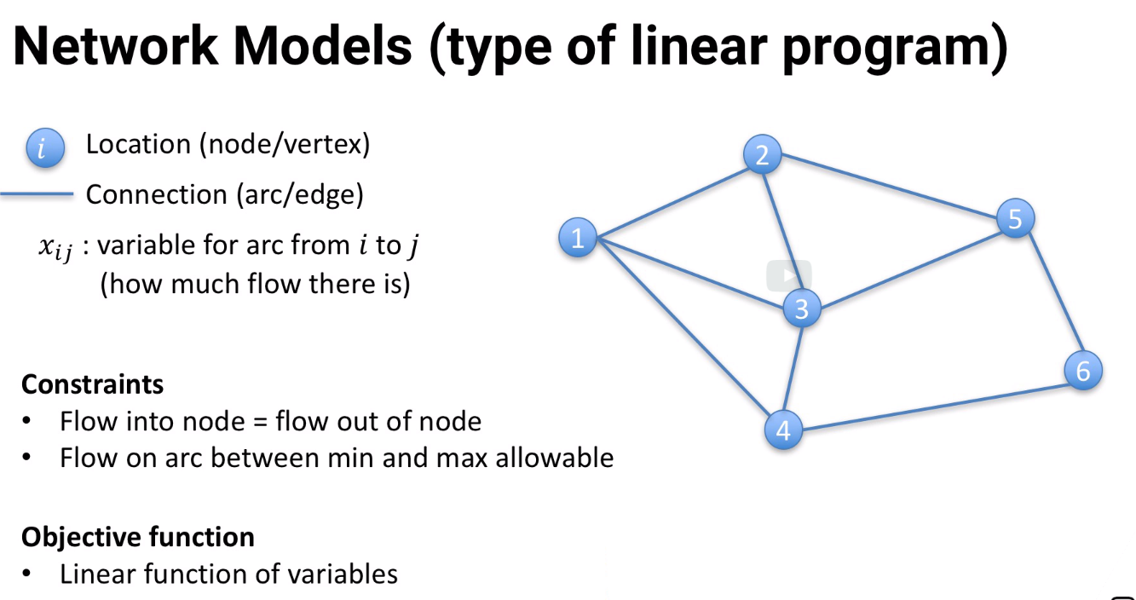

**variable** => shows how much flows from node i to node j.

**constraint:**

1) For each node i, however much flows into j has to equal the amount that comes out of i.

That includes the possibility that some flow enters or leaves the network as node i.

2) For each arc we can have constraints on the minimum and maximum flow

**objective** function is a linear function of variables.

If above criterias are met, it is a network program and it can be solved very easily using specialized mode;

**NOTE:** If all data is integer,then all optimal variable values will be integer without us enforcing it through constraints

## Why network model?

-most common is google maps or gps. Starting from one place what is the shortest route?. This is called “**SHORTEST PATH PROBLEM”**

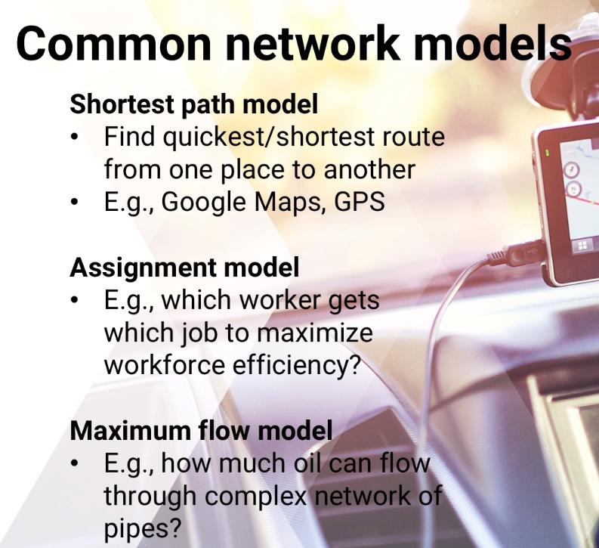

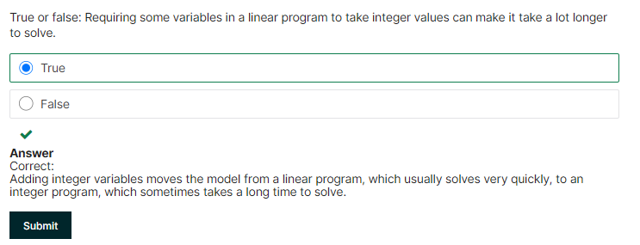

# 11.3 STOCHASTIC OPTIMIZATION

**Implicit Assumption**

* We know all input data
* For every parameter ( say number of additional votes a candidate get for new status he visit) is treated as known value
* Forecast(ROI on a stock) , we assume the expected value with no uncertainty and use that expectation in our possible outcomes

**Agenda:**

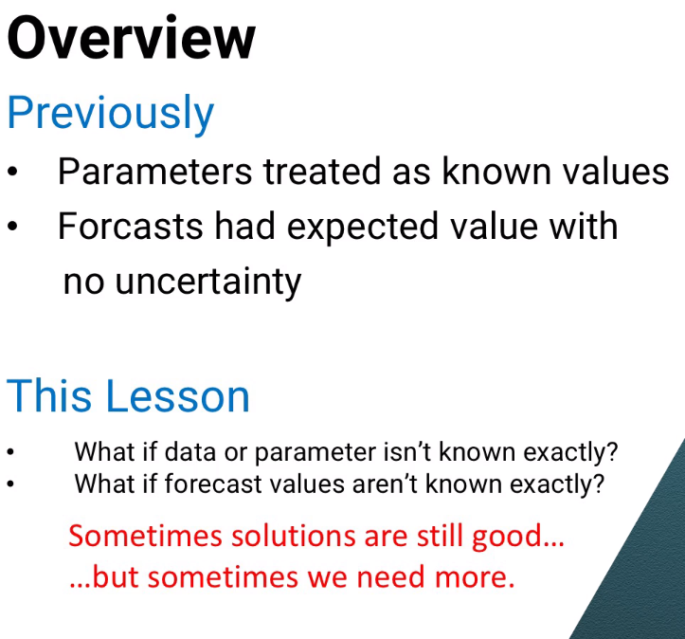

**Approach:**

## Option1: Simple : conservative in modeling

Example: when we have constraint to make total number of workers to be atleast greater than or = demand

**Initial**

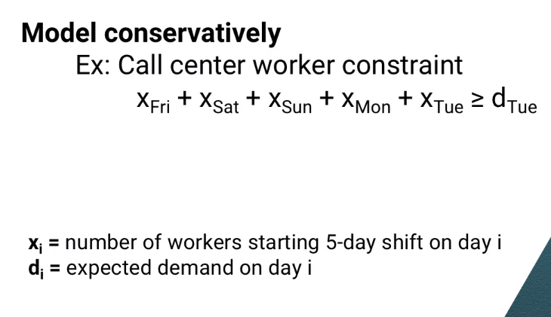

**Conservative**

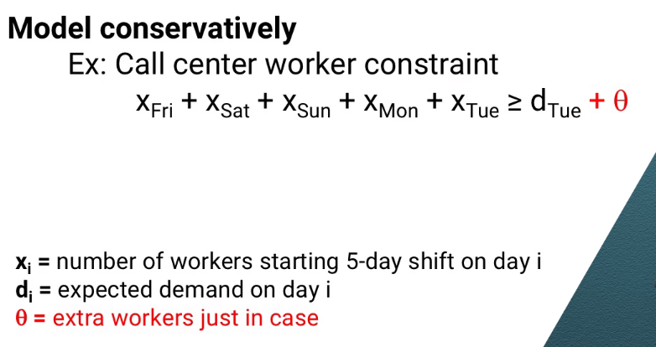

* this way likely to have a few extra workers now on most days, but it's less likely to have too few workers on days when demand happens to be higher than the expectation.

## Alternate: Chance constraint

* **If we have a good estimate of the probability distribution for demand,**

we can even write a chance constraint the probability of having enough workers to meet demand must be at least some value p.

* In any option, we have to pick values for theta (or) p.

## Option2: Scenario modeling

**What?** define one or many scenario and optimize for all of them

**Example:**

Say, bugs can be discovered during rollout which could affect the release of a product

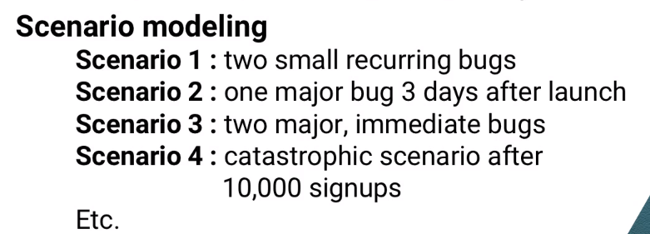

In our worker example,we add new variable “d(is)”

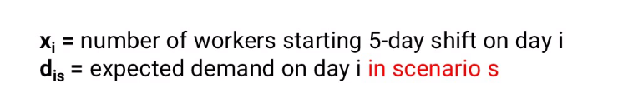

**Next step:**

Pick model that fits all scenarios

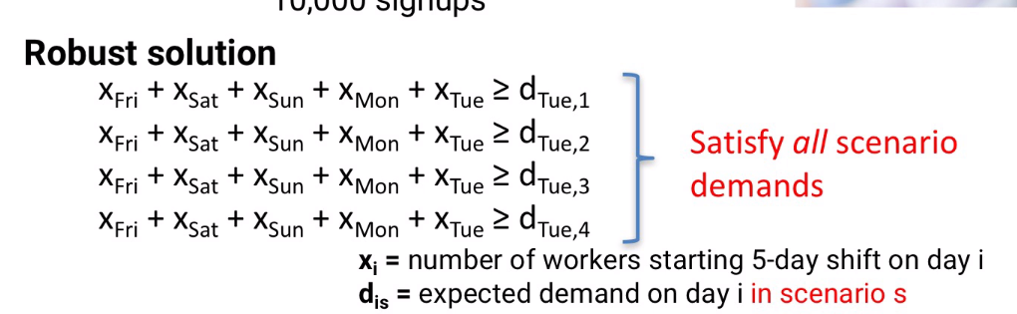

THIS IS CALLED **ROBUST SOLUTION**

**Disadv :**

1. Satisifies all possible scenarios are expensive

So alternate Option…Optimize Expected cost

* i.e In addition to cost of paying workers , add additional cost of having few workers to meet demand
* since we have lot of scenario, we need to estimate probability of each scenario occurring

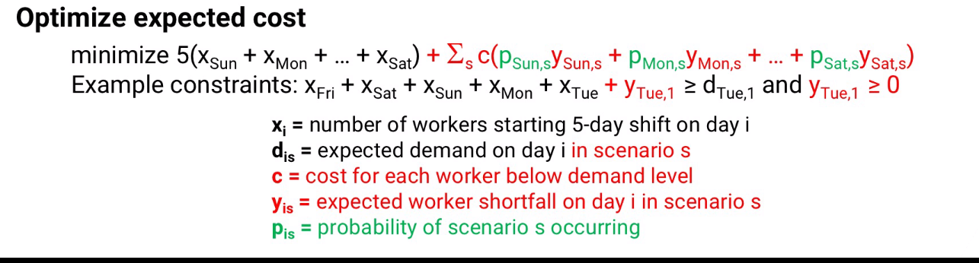

**Disadv:**

1. lots of scenario
2. each scenario has seprate constraint
3. means, optimization could be very large, hard to solve, then try for heuristic (hoping that a good one)

All the above are mathematical models. Other models have different structure

## DYNAMIC PROGRAMMING

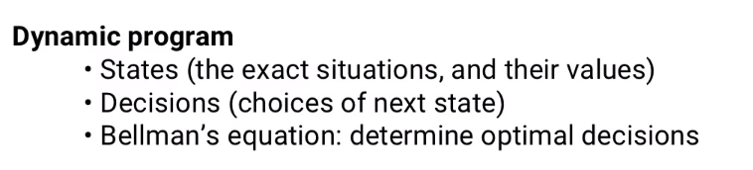

States = > what going on system (like, state can be one week into the rollout week)

Decisions => choices of next state (like how many people should start their 5- day working week tomorrow)

Using BELLMAN” equation, we decide the optimal decision to make at every state

**Assumption:**

* assumes no uncertainty, given state and decision, we know exactly what next state is

## STOCHASTIC DYNAMIC MODEL

This is dynamic progam+decisions have probabilities for next state

## MARKOV DECISION PROCESS

* if discrete set of states and decision
* prpbablity depend only on the current state

## APPROXIMATE DYNAMIC PROCESS

* allows to truncate the calculation

**Summary:** many ways to deal with uncertainty and optimization problems.some are mathematical..and some are dynamic…they give good prescitpive analytics even when data and forecast are not know exactly

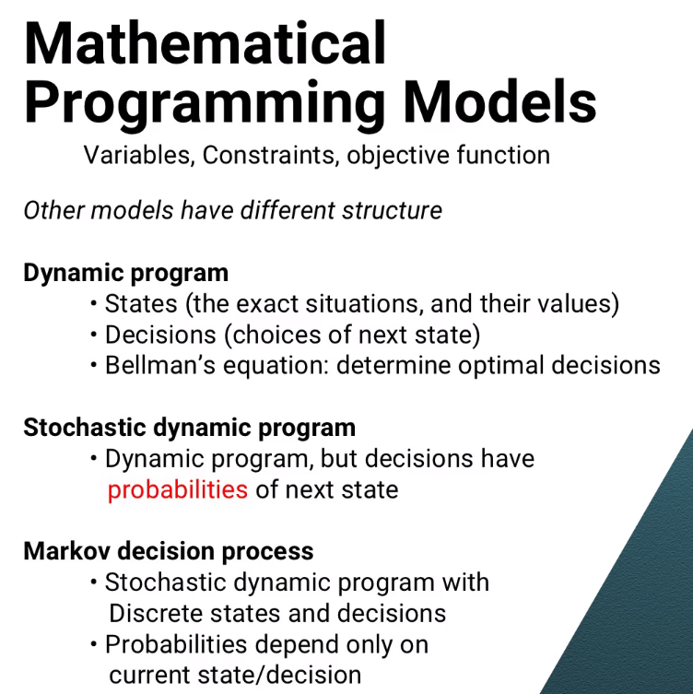

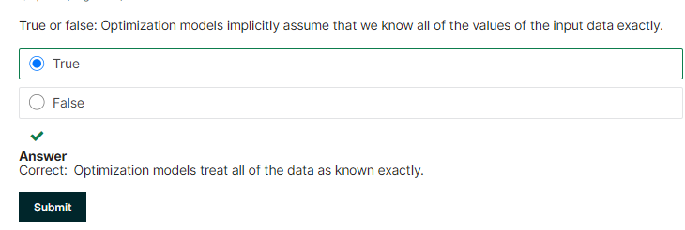

# 11.4 BASIC OPTIMIZATION ALGORITHMS

Agenda: previous,, we saw how to build models, now we are going to see how to solve them

### General idea of Optimization algorithm to solve

Step1: Initialization step

Step2: create vector of relative changes to make to each variable. This vector is called Improving directions

* make changes to improving direction by some amount. That amount Is called step size
* t => improving direction vector
* theta => step size

Step3: we iterate, repeating until when the solution doesn’t change much (or) we run out of time

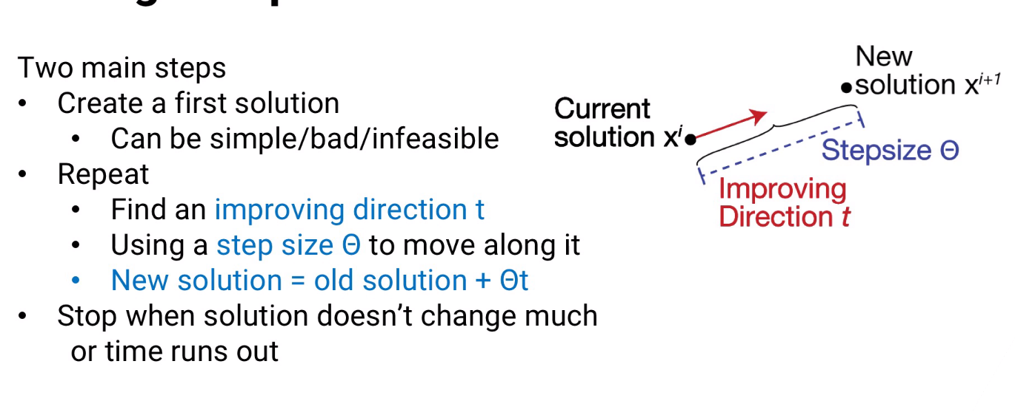

* This sort of algorithm is familiar in calculus , called Newton method; method to find the function’ root (point when the function intersects x-axis)

**Newton’ method**

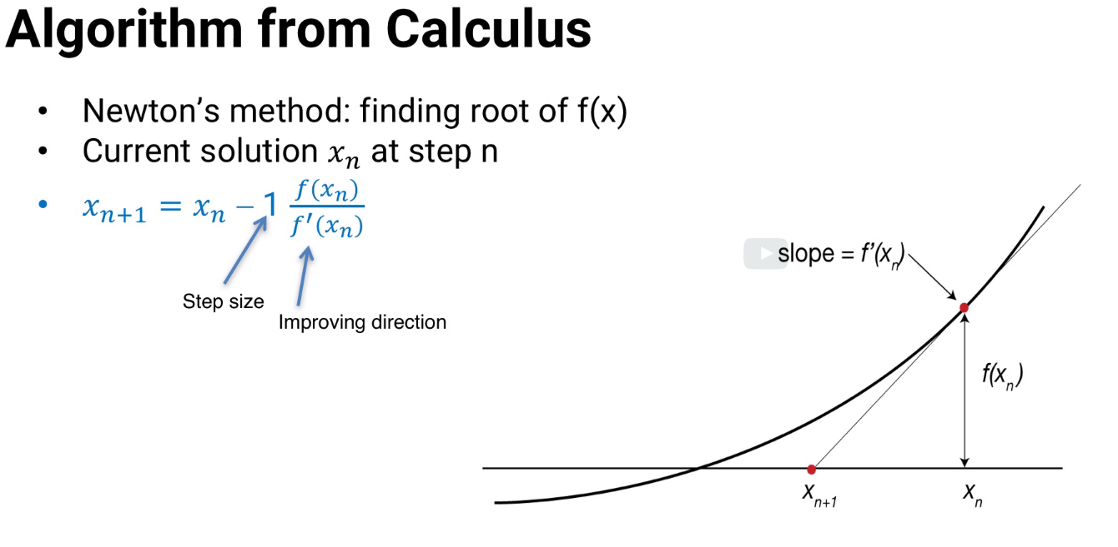

* Convex: this approach is guaranteed to find the optimal solution
* Non convex: not guaranteed. But, method might converge to a solution that’s not in set of feasible solution.

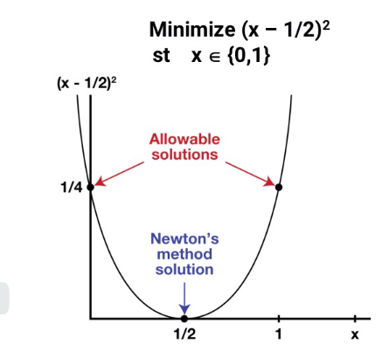

Newtons’ method find intersection of x-axos and that is correct. But other points are not

Next option is it might converge to local solution and not global , like the one below

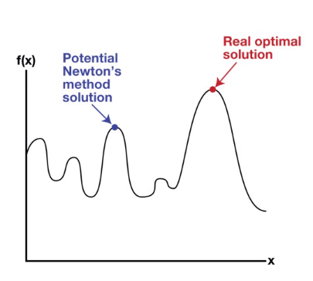

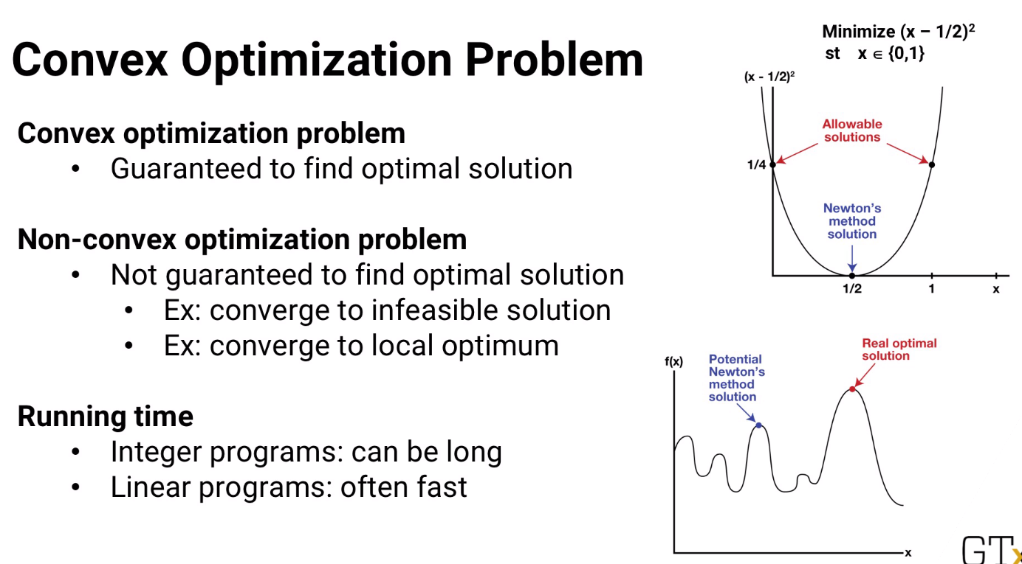

As shown above, integer program can take long time, iiner/network model is faster

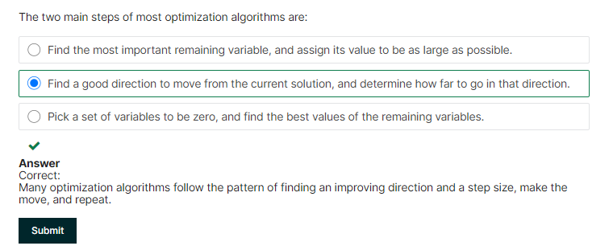

# 11.5 NON PARAMETRIC METHODS

**Agenda:** advanced statistical models

Usually hypothesis test, assume that we know underlying distribution that is used to test.

But sometimes, all we have is the “response” of the test

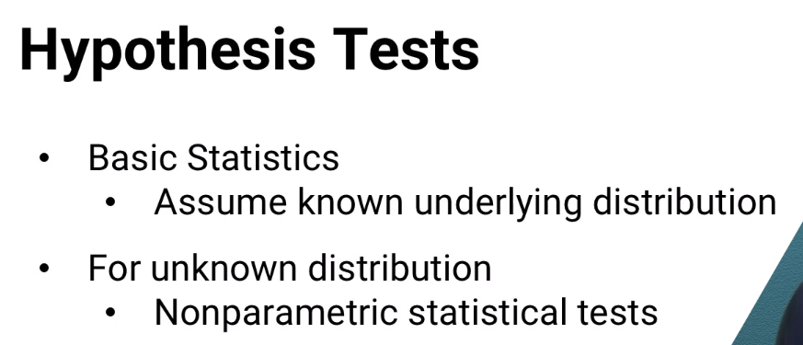

### Mcnemar’ test

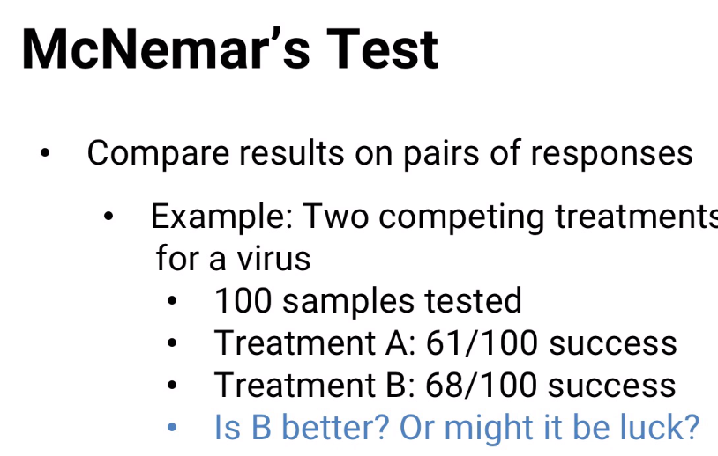

-Both tested for same data set

**Two Scenarios:**

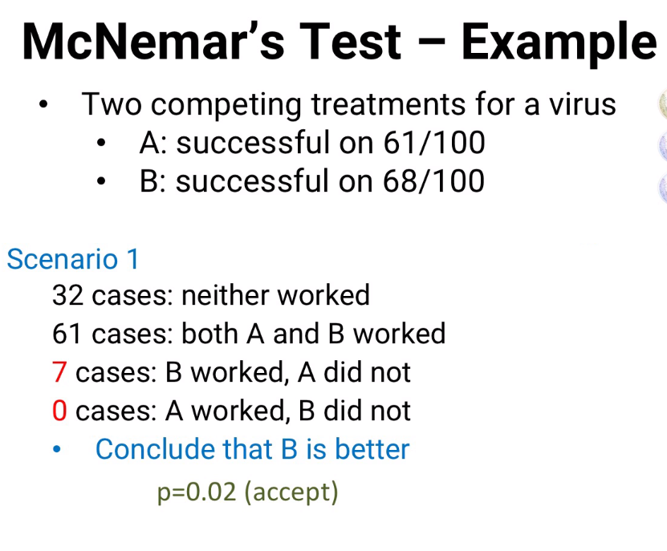 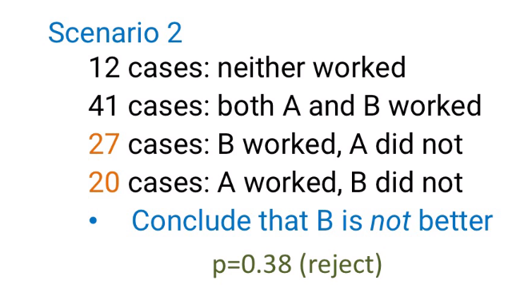

Scenario#2: This is great results. As both will work

But, How to tell statistically?



* We reject ALL other success scenarios
* From scenario#1, p value is 0.02 , which means we have 2% chance that we see the results by luck
* From scenario#2, p value is 0.38 , which means we have 38% chance that we see the results by luck

This is how Mcnemar’ test work

### Wilcoxon Signed Rank test

**Assumption :**

* No assumption on response function mathematically
* Only assumption is distribution is continuours and symmetric

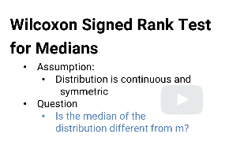

**Approach:**

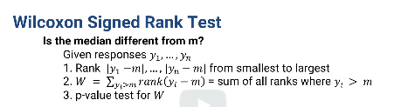

1. Take absolute value of differences of of responses vs. “m”(a selected median)
2. W= Sum all rank only when response > m
3. Find probability of “W”.
4. If the probability p of getting a sum of ranks at least as extreme as W is small, then we can say that the median is probably different from m.

**Variation of Wilcoxon to compare two separate results for different dataset (similar to Mcnemar)**

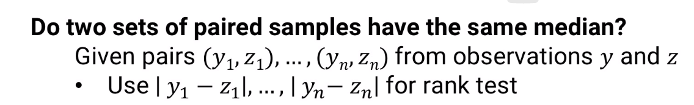

-use difference of y(i) and Z(i) instead of using “m”

- Here what we are answering is

“whether the ranks indicate that the two sets of observations are likely to be different.”

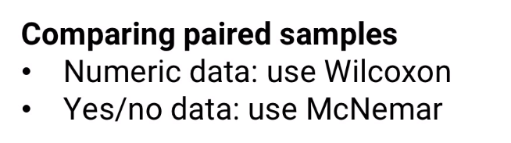

**Compare & Contrast**

|  |  |  |
| --- | --- | --- |
| Non parametric test/comparison | McNemar | Wilcoxon |
| dist. | binomial | normal dist. |
| easiness | easier | harder to find p value |
| dataset | same data set and samples | different datasets |
| Used for comparing paired samples | yes/no data: use mcnemar | NUMERIC - use Wilcoxon |

### Mann- Whitney

* 2 dataset (NOT PAIRED samples)
* meaning the observations for Mcnemar and Wilcoxon uses observation of same virus. Here it is independent

**Approach:**

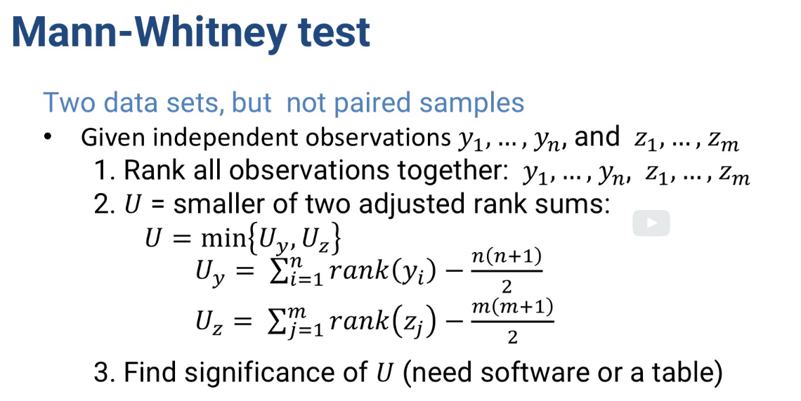

* two different dataset from two different virus
* two datasets can have different rows
* no exclusions..get rank of both the observations and find the smallerst of the adjusted rank’ sum
* this is compared against the table to find significance of difference “U”

**Summary:**

These approaches are useful even when we don’t know much about underlying process that creates the observation, we can still use relative ranks, competing outcomes to see the difference between them

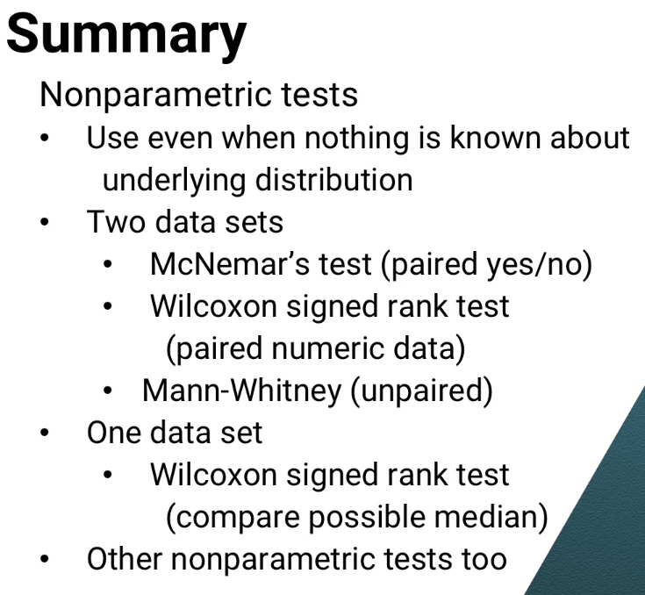

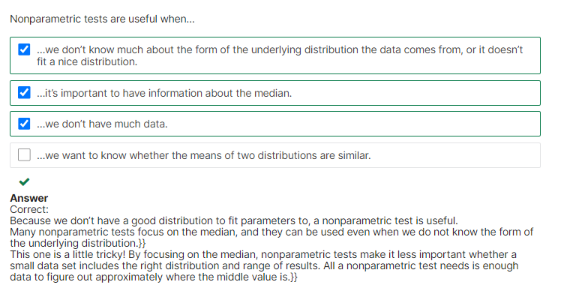

# 11.6 Bayesian Modeling

**Agenda:**

Bayesian models

How they are counter intuiative

**Example1 :**

-based on basic rule of conditional probability – Bayes rule or bayes theorem

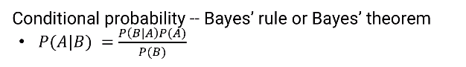

Probability of A given B = probability of B given A *probability of A / probability of B

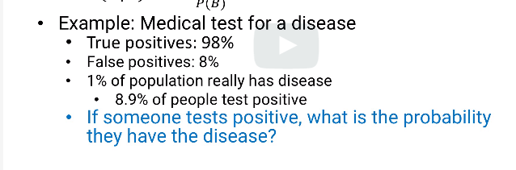

**Question**: If someone is tested, what are the possibilities that he has the disease

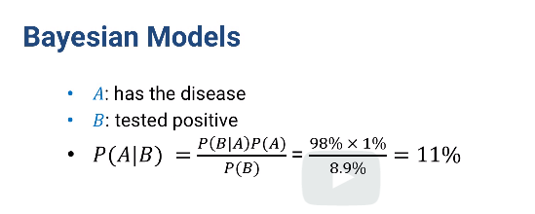

B given A: tested positive (b) given he has the disease(a)

A given B : probability of having disease(a), when tested positive(b)

i.e even after testing positive, the person has only 11% of having the disease??

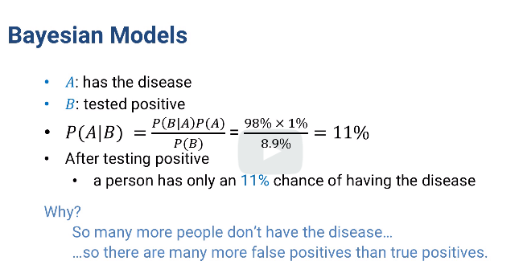

## Empirical Bayes Modeling

**Common usage**: overall distribution of something is known and estimated, but only little data available for specific case

Question to answer: how much better one team than another in basketball

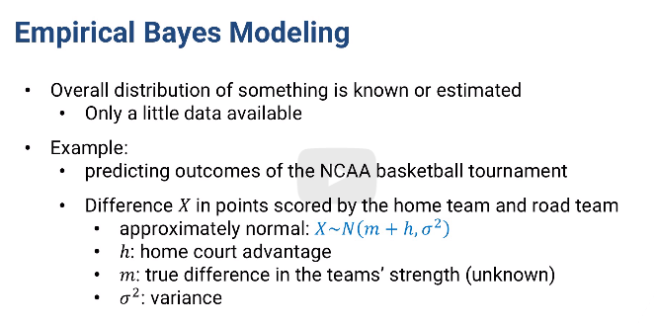

* difference “X” between home and road team is normally distributed with variance (sigma squared)
* mean = home court advantage(h)+m(true difference in team strength)
* **don’t know :m**
* using bayes rule, we can figure it out
* diference “M” of how good teams are is normally distributed with mean 0 and variance tau squared
* 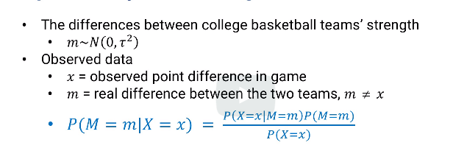

We can say observed “x” = m(Actual difference), but that doesn’t account for all the randomness of a game

So here is how we calculate,

-find probability of having true difference “M” given actual observed “x” which is

Probability of X (True observation) given true margin * probability of true margin “M”/ probability of observed margin “x”

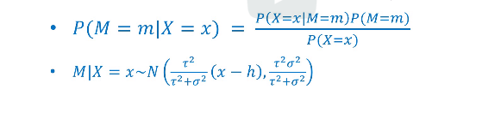

I true differen “m” is alsonormally distributed with mean and variance shown here –

First parameter within N() is mean and the secnd is variance

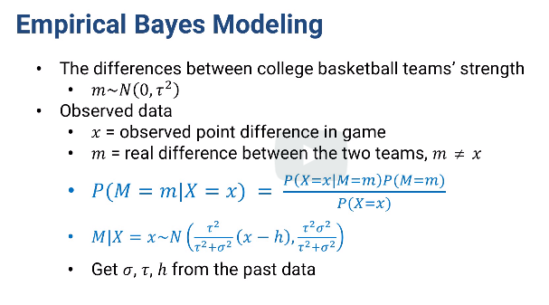

Given all co-efficients from past value, we can get how much better or worse our team is than the other

-we can also integrate that distribution from 0 to infinity to show the probability of Georgia tech being better team

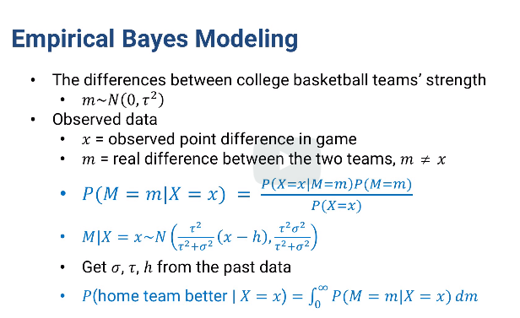

Lets see the data

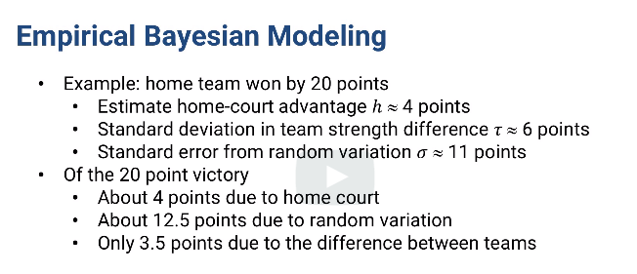

* Based on data above, we see only 3.5 points that the team is truly better than the other and if we don’t play in home court(h=4 points), we might lose?
* Reason is variance = square of standard deviation =6*6= 36
* Variance doe to randomness =120
* So there is lot of variance due to randomness

**Summary:**

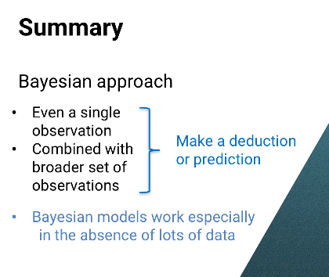

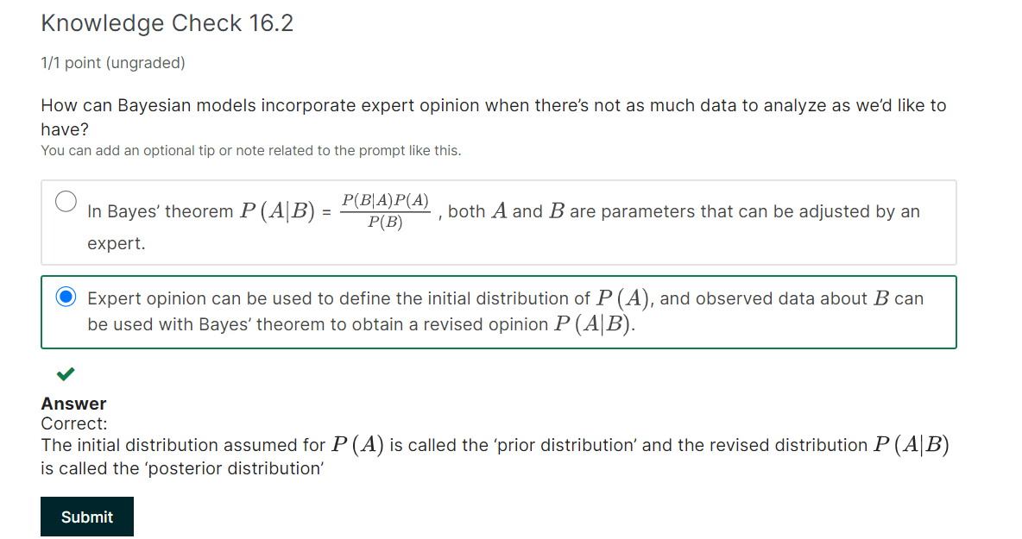

# 11.7 Communities in the graph

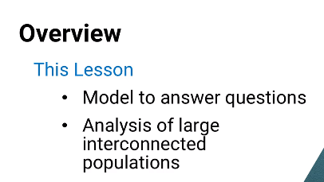

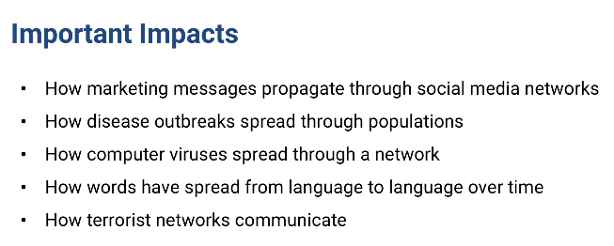

Within subpopulation, things can spread more quickly

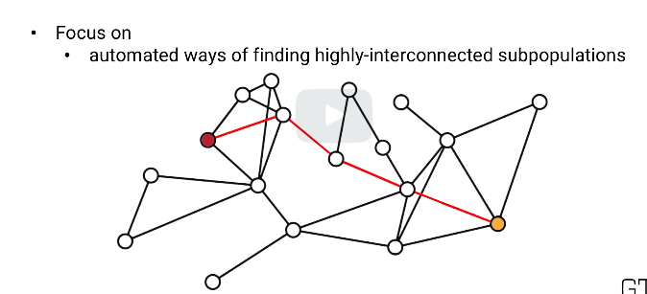

Above diagram takes long time to propogate from person red to person yellow

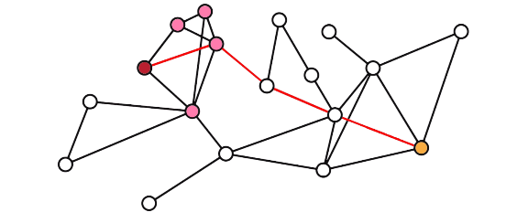

Bt pink and red are more closely connected

-sae is applicale sendig marketing message from red to pink

**Objective**: see a model to quiclly and automatically finding community like red and pink within a population’

## Standard Terminology

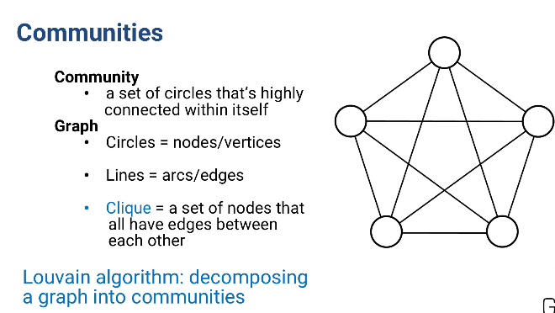

It pronounced clee-iq. It small community that stick together and excludes others

Process of finding cliques is mathematically hard problem to solve, our question is different here

* We don’t need full cliques
* Communities with lots of edges between nodes are also valuable to fin even if the edcges missing from what would be cliques

## Louvain Algorithm : decomposing a graph into communities

Weight of arc : how important an arc is

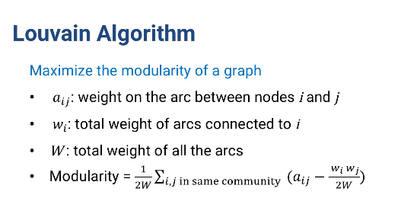

If no arc between between “I” and “j”, then a(ij)=0

**Modularity : how well graph is separated into communities or modules that are connected well internally but NOT within each other (communities/modules)**

## Louvain Algorithm Steps

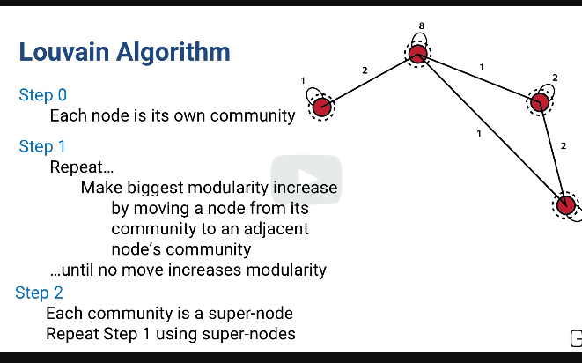

* If nothing increases modularity node “I” stays as it is
* It starts on node “0”, goes through all nodes and repeats back to node 0 and goes again and again until no change to modularity is noticed
* Last step is its makes a community as super node with total weight of all the nodes in it
* Super arcs are created between super nodes with total weights of all arcs inside the super nodes within in
* R and python already have Louvain algorithm in it
* It is Heuristic, but quick fast . used to find communities within large network, e.g social media

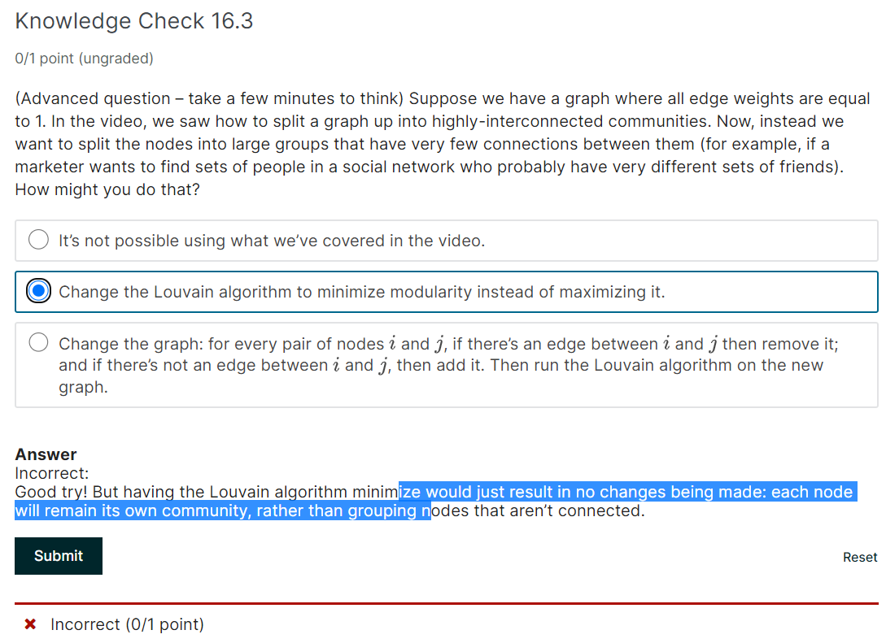

Correct option:

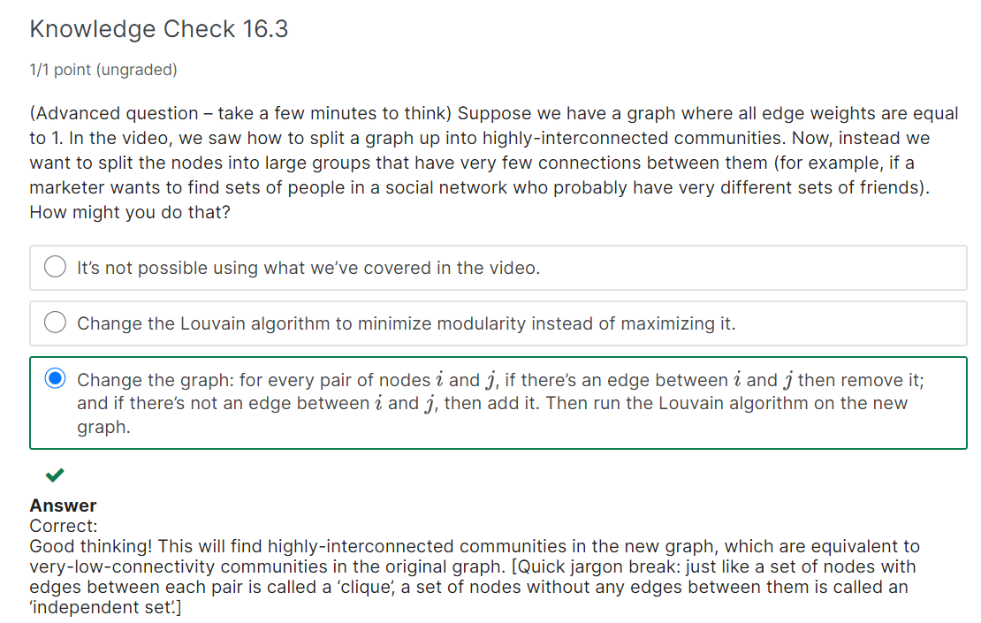

# 11.8 Neural and Deep Learning

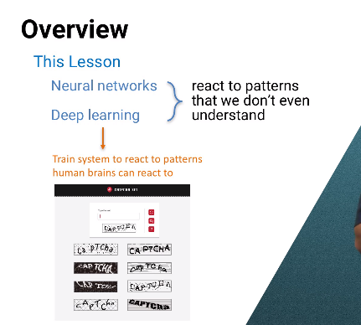

* Easy for human to understand.
* Neural netowkr- train the model to react without even knowing what they are reacting to
* Speech, writing, NLP and text minig

## Elements of Neural network

* Artigical neural has 3 layers
* External input come to each input neuron
* If trying to solve captcha problem,we divide picte in picel and every pixel’ state between white and black goes to its own neuron input
* 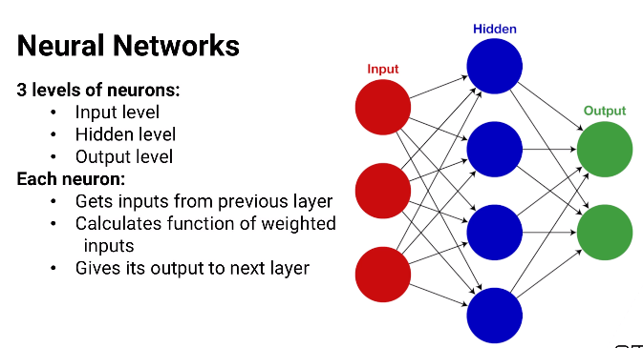
* -each simulated nuerun calculates weighted inout and send to next layer which again does the same thing
* There may be more than one hidden layer
* Common capcha is one output neuron for each possible number of letters
* -this gives level of certainty and model’ predicted output is whichever that has the highest output
* Then is the important **step. Based on how wrong the results are, the weights are changed within all simulated neurons**
* There are many way to do this. Simple one is Gradient descend using slope of the function from calculus

## Practical challenges

* Not useful
* Lots of data to train
* Hard to choose and tune the learning algorithm but wweights don’t change too slowly but also don’t change too quickly that they jump all over the place

## Deep Learning

* More successful thatn neural
* Similar to neural
* Have lot of layers
* Better approach, areas like nlp, speech and image processing, research topics text and language

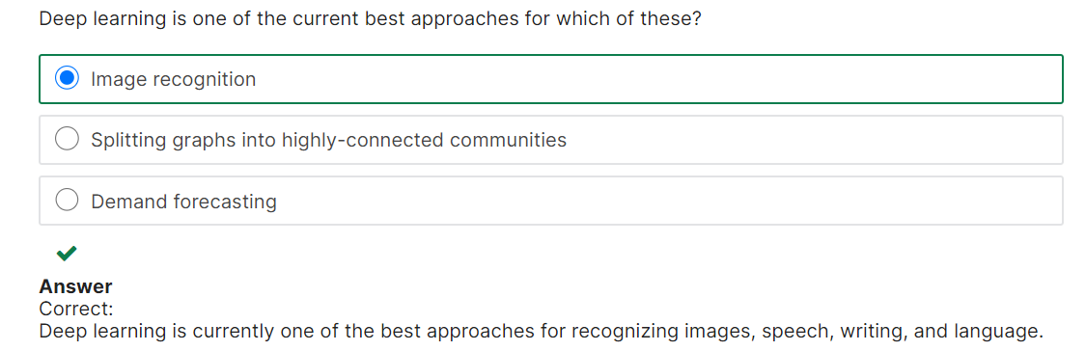

# 11.9 Competitive Models

Competive decision making

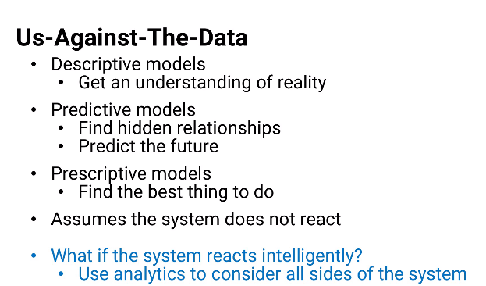

Models t hat consideres all sides of system

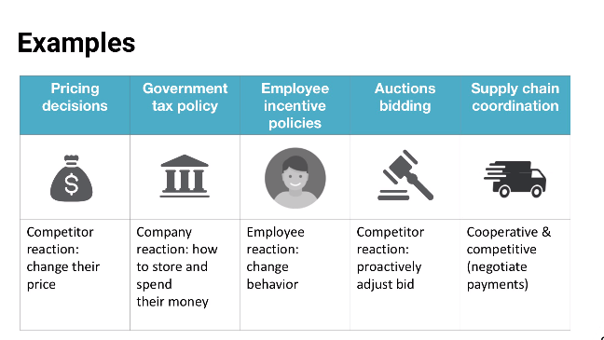

Competitive and cooperative: supply chain – intel chip on lenova laptop

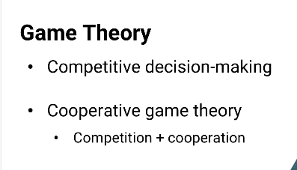

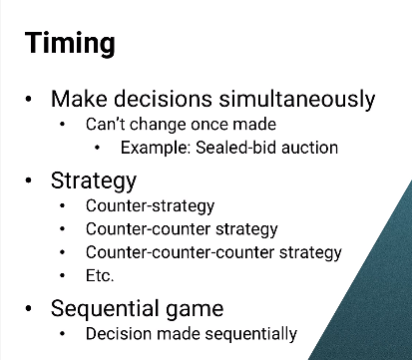

In gas station example, the best strategy was to do one thing. This is called “PURE STRATEGY”

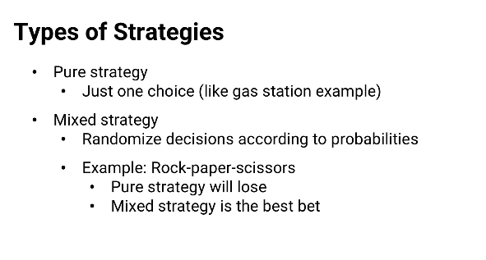

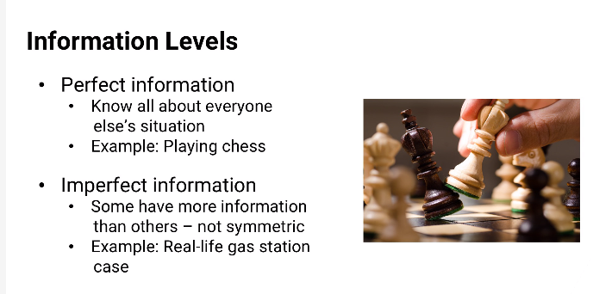

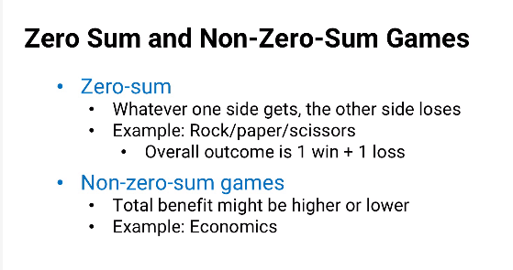

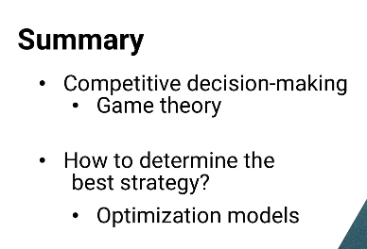

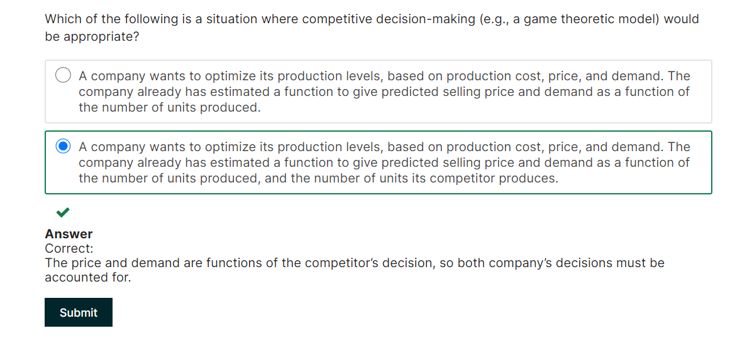

# 11.10 competitive model demo

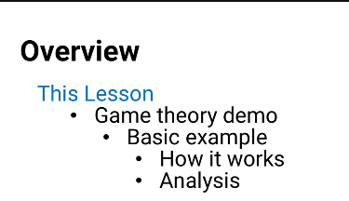

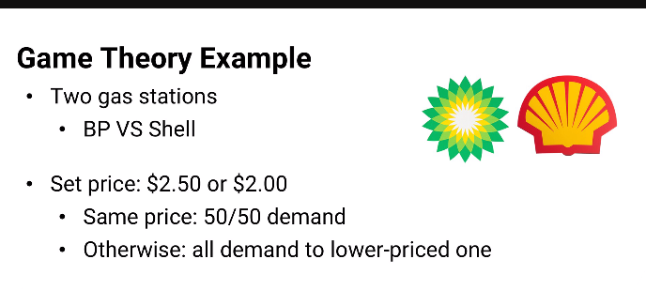

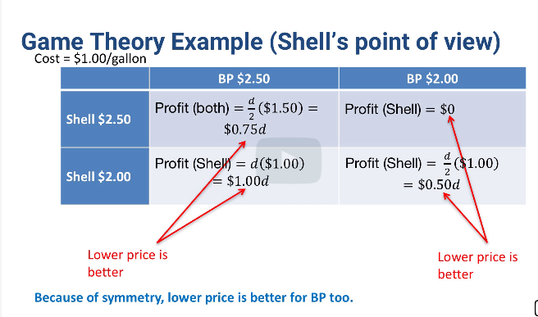

## Stable quilibrium

[1]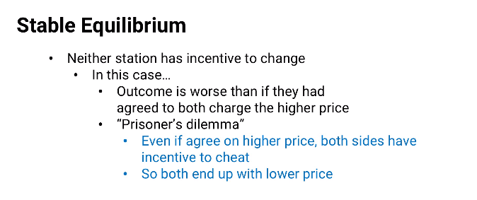

Prisoner dilemma: math assume prisoner dilemma and assume both companies doesn go with higher prices

**Re-do for a smaller cost margin..**

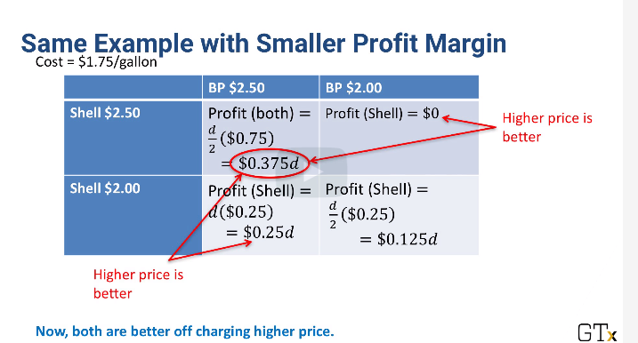

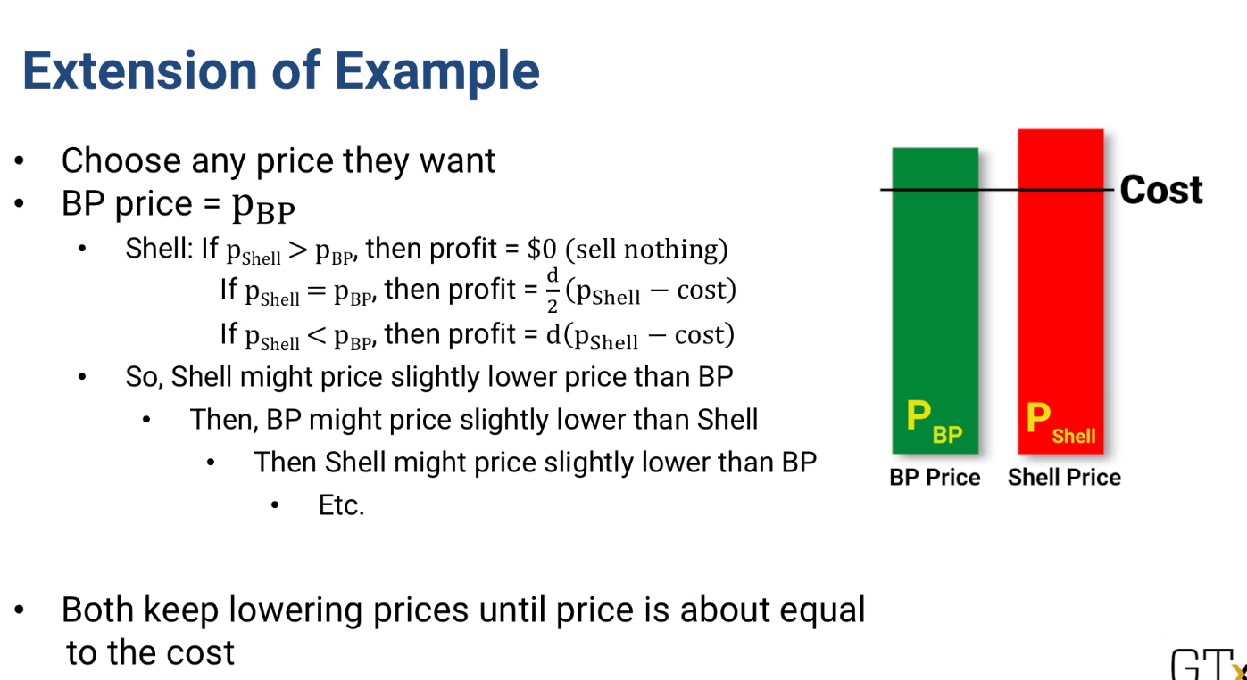

* **This model is why competition tends to drive lower prices**

1.